

OOP Lab-11 Tasks

Name: Syed Muhammad Raza Ali

Enrolment: 02-134231-028

Course: OOP Lab

Faculty: Miss Hafsa Munawar

|  |
| --- |
| **Lab11: Exception Handling** |

In Lab following topics will be covered:

|  |
| --- |
| 1. Exceptions 2. Types of Exceptions |

|  |
| --- |
| **Exercises** |

Exercise

Create a program that has class of Mathematical Operations on Matrices and Apply all Exception Handling that can occur e.g. IndexOutOfRange or StackOverflow etc.

Program must perform

1. Addition of two matrices (A+B)
2. Subtraction of two matrices (A-B)
3. Scalar Multiplication with Matrix (x*A)
4. Consider A and B as matrices and x as any scalar value other than 0

Code:

# Matrices Class

package com.mycompany.exceptionhandling;

import java.util.InputMismatchException;

import java.util.Scanner;

public class Matrices{

protected int[][] A = new int[3][3];

protected int[][] B = new int[3][3];

Scanner sc = new Scanner(System.in);

//methods

public void takeInputInA(){

try{

System.out.println("===== Input In A =====");

for(int i = 0;i<A.length;i++){

for(int j = 0;j<A.length;j++){

System.out.println("Enter the value of position "+i+j+" : ");

A[i][j] = sc.nextInt();

}

}

}

catch(IndexOutOfBoundsException | NullPointerException | InputMismatchException e){

System.out.println(e.getMessage());

}

}

public void takeInputInB(){

try{

System.out.println("===== Input In B =====");

for(int i = 0;i<B.length;i++){

for(int j = 0;j<B.length;j++){

System.out.println("Enter the value of position "+i+j+" : ");

B[i][j] = sc.nextInt();

}

}

}

catch(IndexOutOfBoundsException | NullPointerException | InputMismatchException e){

System.out.println(e.getMessage());

}

}

}

# Equation1 Class

package com.mycompany.exceptionhandling;

import java.util.InputMismatchException;

public class Equation1 extends Matrices{

private int[][] result = new int[3][3];

public Equation1() {

}

public void calculateSum(){

try{

for(int i = 0;i<result.length;i++){

for(int j = 0;j<result.length;j++){

result[i][j] = A[i][j] + B[i][j];

}

}

System.out.println("===== A+B =====");

for(int i = 0;i<result.length;i++){

for(int j = 0;j<result.length;j++){

System.out.print(result[i][j]+" ");

}

System.out.println("\n");

}

}

catch(IndexOutOfBoundsException | NullPointerException | InputMismatchException e){

System.out.println(e.getMessage());

}

}

}

# Equation2 Class

package com.mycompany.exceptionhandling;

import java.util.InputMismatchException;

public class Equation2 extends Matrices{

private int[][] result = new int[3][3];

public Equation2() {

}

public void calculateDifference(){

try{

for(int i = 0;i<result.length;i++){

for(int j = 0;j<result.length;j++){

result[i][j] = A[i][j] - B[i][j];

}

}

System.out.println("===== A-B =====");

for(int i = 0;i<result.length;i++){

for(int j = 0;j<result.length;j++){

System.out.print(result[i][j]+" ");

}

System.out.println("\n");

}

}

catch(IndexOutOfBoundsException | NullPointerException | InputMismatchException e){

System.out.println(e.getMessage());

}

}

}

# Equation3 Class

package com.mycompany.exceptionhandling;

import java.util.InputMismatchException;

public class Equation3 extends Matrices{

private int scalarValue;

public Equation3() {

}

public void calculateProduct(){

try{

System.out.print("Enter a value : ");

scalarValue = sc.nextInt();

for(int i = 0;i<A.length;i++){

for(int j = 0;j<A.length;j++){

A[i][j] *=scalarValue;

}

}

System.out.println("===== A*B =====");

for(int i = 0;i<A.length;i++){

for(int j = 0;j<A.length;j++){

System.out.print(A[i][j]+" ");

}

System.out.println("\n");

}

}

catch(IndexOutOfBoundsException | NullPointerException | InputMismatchException e){

System.out.println(e.getMessage());

}

}

}

# Equation4 Class

package com.mycompany.exceptionhandling;

import java.util.InputMismatchException;

public class Equation4 extends Matrices{

private int scalarValue;

private int[][] result = new int[3][3];

public Equation4() {

}

public void calculateProduct(){

try{

System.out.println("Enter a value : ");

scalarValue = sc.nextInt();

if(scalarValue==0){

System.out.println("Enter a non zero value....");

}

else{

for(int i = 0;i<A.length;i++){

for(int j = 0;j<A.length;j++){

result[i][j] =A[i][j] * B[i][j]*scalarValue ;

}

}

}

System.out.println("===== A*B*scalarValue =====");

for(int i = 0;i<A.length;i++){

for(int j = 0;j<A.length;j++){

System.out.print(result[i][j]+" ");

}

System.out.println("\n");

}

}

catch(IndexOutOfBoundsException | NullPointerException | InputMismatchException e){

System.out.println(e.getMessage());

} }}

# Application Class

package com.mycompany.exceptionhandling;

public class ExceptionHandling {

public static void main(String[] args) {

//for equation1

Equation1 obj = new Equation1();

obj.takeInputInA();

obj.takeInputInB();

obj.calculateSum();

//for equation2

Equation2 obj = new Equation2();

obj.takeInputInA();

obj.takeInputInB();

obj.calculateDifference();

//for equation3

Equation3 obj = new Equation3();

obj.takeInputInA();

obj.takeInputInB();

obj.calculateProduct();

//for equation4

Equation4 obj = new Equation4();

obj.takeInputInA();

obj.takeInputInB();

obj.calculateProduct();

}

}

Output:

# For Equation1

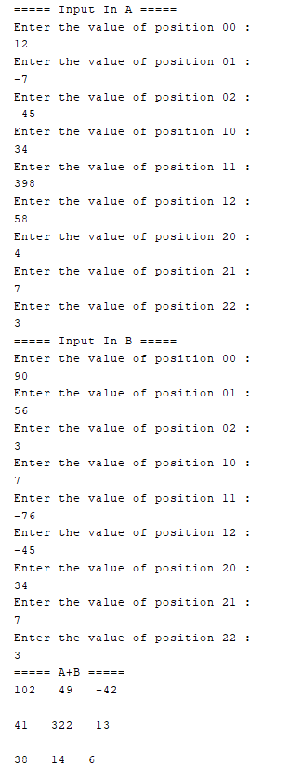

# For Equation2

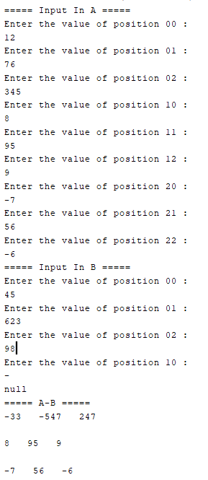

# For Equation3

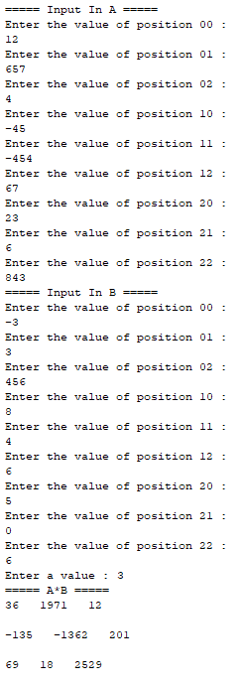

# For Equation4

